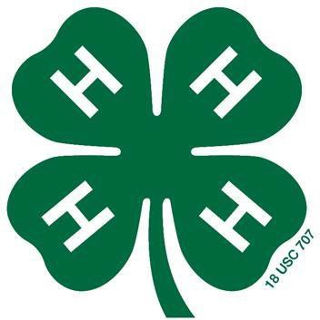
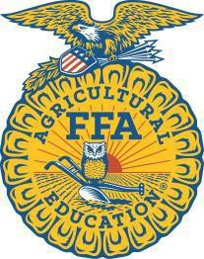
Polk County 4-H & FFA Fair
1625 Adventureland Drive
Altoona IA 50009

Dear Friends,

The Polk County 4-H & FFA Fair gives over 600 Polk County youth the opportunity to exhibit projects about anything from astronomy to zoology. Each year these young people show their animals, practice their communication skills, help each other as they work toward their goals, and most importantly have fun. The county fair is an experience like no other, and we invite you to be a part of it through your sponsorship.

We offer several levels of sponsorship to meet the needs of a variety of organizations; the various options are listed on the back of this letter.

Please consider sponsoring the 2026 Polk County Fair. Thank you in advance for helping make the county fair a memorable experience for our 4-H and FFA members.

If you have questions, please call Chad Allen 515-418-8308.

The Polk County 4-H & FFA Fair Association Board

Business Organization Name: _______________________________________________________________

Contact Person: __________________________________________________________________________

Address: ________________________________________________________________________________

Phone: __________________________________ Email: _________________________________________

Website: ________________________________________________________________________________

Tell us about your business/organization (Please write what you would like to be shared during a show):

______________________________________________________________________________________

______________________________________________________________________________________

______________________________________________________________________________________

Make checks payable to: Polk County 4-H & FFA Fair Association

Polk County 4-H & FFA Fair Association is a 501(c)3 organization

Polk County 4-H & FFA Fair Corporate Sponsor Levels

Gold Level – Corporate Sponsors - $15,000+
- Top recognition on Polk County Fair website*
- Recognition in every show book at the Polk County Fair
- Verbal recognition during all the shows at the Polk County Fair
- Three banners** with your logo/name displayed during the Polk County Fair
- Opportunity to speak about your business at the awards ceremony during the Polk County Fair BBQ

Silver Level – Corporate Sponsors - $7500-$14,999
- Special recognition on Polk County Fair website*
- Recognition in every show book at the Polk County Fair
- Verbal recognition during all the shows at the Polk County Fair
- Two banners** with your logo/name displayed during the Polk County Fair
- Verbal recognition at the awards ceremony during the Polk County Fair BBQ

Bronze Level – Corporate Sponsors - $2500-$7499
- Special recognition on the Polk County Fair website*
- Recognition in every show book at the Polk County Fair
- One banner** with your logo/name displayed during the Polk County Fair

Purple Level - $100-$2499
- Recognition on the Polk County Fair website
- Recognition in every show book at the Polk County Fair

